How to Distribute Palm Ashes

Thank you for offering to help distribute the ashes on Ash Wednesday.

The practice of marking ashes on the forehead relates back to the ancient times, when ashes were used to reveal sorrow and mourning.

We put the sign of the cross on each other’s foreheads as a public and communal sign that we wish to reflect on our sins and to ask for forgiveness.

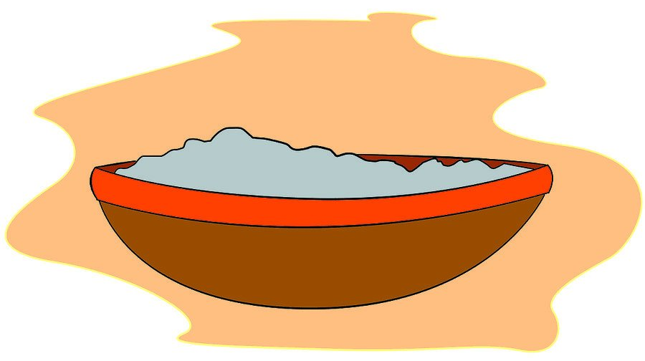
Step 1
The distribution takes place after the Gospel. The distributors will be invited by the Priest to come up to the altar to pick up their bowl. They will then walk to the spot they have been allocated on the plan (see overleaf).

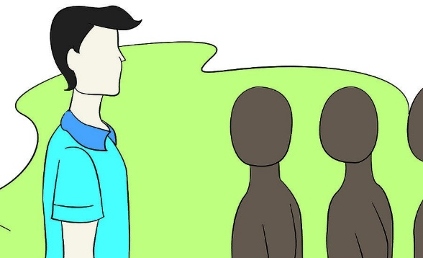
Step 2
Stand in your designated spot.
A group of the congregation will begin to line up in single file in front of you.

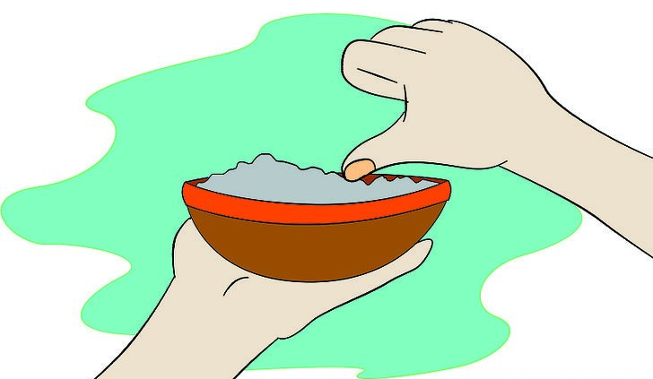
Step 3
Place your right thumb into the container of ashes, which you should hold in your left hand. Make sure that there are enough ashes on your thumb to properly apply them to a person's forehead.

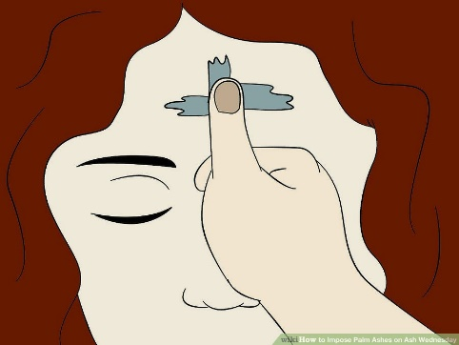
Step 4
With your right thumb, apply the ashes to the first person's forehead, in the shape of a cross.
While applying the ashes, say the following phrase to the person:
Repent and believe in the Gospel

Please memorise the phrase.

Step 5
After distributing your ashes return the bowl back to the table. There will be a bowl of water available for you to wash your hands.

